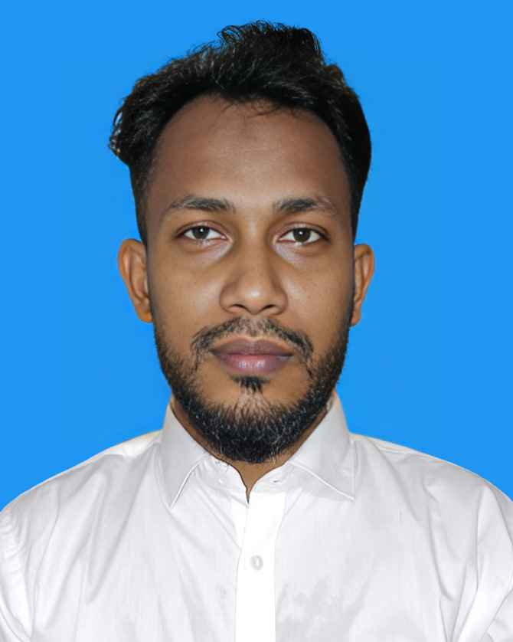

Software Engineer | Full Stack Developer
Phone: +8801822969122
WhatsApp: +8801822969122
Email: enamulhoque007m@gmail.com

RESUME OF

ENAMUL HOQUE

LinkedIn: https://www.linkedin.com/in/enamul-hoque-1a517a141 GitHub: https://github.com/enamul007
Address: 1768, South Manda, Dhaka-1238

CAREER OBJECTIVE
A passionate and solutions-driven Software Engineer with proven experience in developing full-stack web applications using modern technologies. Adept at designing clean, scalable, and maintainable systems with a strong focus on performance, security, and user experience. I am seeking an opportunity in a forward-thinking organization where I can contribute to impactful projects, collaborate with innovative teams, and continuously grow through challenging real-world problem-solving.

CAREER SUMMARY
Accomplished Full Stack Developer with a proven history of delivering enterprise-grade applications across diverse sectors such as ERP, ISP management, and e-commerce. Experienced in modern frameworks and programming languages including JavaScript, TypeScript, C#, ASP.Net Core, and SQL Server. Strong background in Agile methodologies, team collaboration, mentoring junior developers, and developing secure, high-performing software solutions.

KEY SKILLS AND EXPERTISE:
- Full Stack Web Development (React, ASP.NET Core) – Capable of designing and developing both client- side and server-side components of scalable web applications.
- Object-Oriented Programming (OOP) – Strong foundation in OOP principles to build maintainable and reusable code structures.
- RESTful API Design & Integration – Skilled in creating, documenting, and consuming robust and secure APIs.
- Database Management & Optimization – Proficient in SQL Server & PostgreSQL with experience in schema design, complex queries, indexing, and performance tuning.
- Modern Front-End Technologies – Expertise in HTML5, CSS3, JavaScript, TypeScript, Tailwind CSS, Ant Design for building responsive and user-friendly UIs.
- Version Control & DevOps Tools – Proficient in Git, GitHub, GitLab, and basic CI/CD pipeline setup for automated deployment and code quality checks.
- Authentication & Authorization – Experience with JWT, OAuth, and Role-Based Access Control (RBAC) implementations.
- Agile/Scrum Methodologies – Comfortable working in Agile environments using tools like Jira, Trello, and participating in daily stand-ups, sprint planning, and retrospectives.
- Software Testing & Quality Assurance – Knowledge of unit testing (xUnit, NUnit), integration testing, and debugging techniques to ensure high-quality software.
- System Design & Architecture – Familiarity with microservices, MVC, clean architecture, and layered application design patterns.
- Cloud Services & Hosting – Basic experience with cloud platforms like Azure or AWS (EC2, S3, Lambda) and deploying web apps.
- Containerization & Virtualization – Understanding of Docker concepts for development and deployment consistency.
- Performance Optimization – Skilled in identifying performance bottlenecks in code and database, improving load times and system responsiveness.
- Leadership & Mentoring – Ability to guide junior developers, conduct code reviews, and share best practices to improve team productivity.
- Continuous Learning & Technology Adaptability – Passionate about learning emerging tools, frameworks, and staying updated with industry trends.

PROFESSIONAL EXPERIENCE:

Software Engineer
Royal Green Limited (September 2020 – Present) Responsibilities:
  - Developed ERP modules including Business, Inventory, Sales, Purchase, HRM, and Ticketing
  - Built cloud-based portals for virtual machine (VM) management
  - Implemented key system integrations for ISP service management
  - Worked directly with clients to define and deliver project requirements

Software Engineer
ESOL (August 2018 – September 2020) Responsibilities:
  - Developed Security Services ERP modules (Inventory, Sales, Purchase) using ASP.NET MVC 5
  - Worked on sobkichu.com e-commerce admin panel, APIs, and payment gateway integration
  - Contributed to an employee tracking system for real-time location monitoring
  - Optimized database queries and performance for MSSQL 2014

Junior Software Engineer
Opus Technology (August 2017 – August 2018) Responsibilities:
  - Contributed to CRM and Sales modules of Credit Rating ERP
  - Built UI components using jQuery, Bootstrap 3.7, and ASP.NET MVC5
  - Developed and maintained stored procedures and SQL queries

EDUCATIONAL QUALIFICATIONS:
- MSc in Chemistry – Dhaka College, 2012, Second Class (58%)
- MSc in ICT – Dhaka College, 2012, A+ 4.00(out of 4)
BSc in Chemistry – Dhaka College, 2011, Second Class (52%)
HSC (Science) – MA Hasem University College, 2006, GPA 4.30 (out of 5)
SSC (Science) – AKP High School, 2004, GPA 4.56 (out of 5)

SPECIAL TRAINING SUMMARY:

Web Development (Dot Net Development)
Institute: BITM, Bangladesh | Location: Kawran Bazar, Dhaka | Year: 2017 | Duration: 3 months

Enterprise Systems Analysis & Design - C#.NET
Institute: IDB-BISEW | Location: Dhaka, Bangladesh | Year: 2016 | Duration: 15 months

ICT (Information Communication Technology)
Institute: Dhaka College | Location: Dhaka, Bangladesh | Year: 2015 | Duration: 1 year

HOBBIES AND INTERESTS:
  - Web development and coding challenges
  - Reading tech blogs and exploring new tools
  - Contributing to open-source projects
  - Traveling, hiking, and photography

EXTRA-CURRICULAR ACTIVITIES:
  - Sports Participation – Actively participated in football and volleyball tournaments at the school and college level, representing the institution in various local competitions. Demonstrated strong teamwork, leadership, and discipline on the field.
  - Cultural Engagement – Engaged in debates, drama, and singing at the college and university level. Developed strong public speaking, communication, and creative skills through active involvement in cultural activities.
  - Community Service – Volunteered in various community service initiatives organized by local NGOs, including blood donation drives and distributing food to the underprivileged. Contributed to the betterment of society and honed a sense of empathy and responsibility.
  - Event Coordination – Assisted in organizing annual college events, including workshops, seminars, and awareness programs focused on student development. Gained valuable experience in event planning, coordination, and managing team collaborations.

PERSONAL INFORMATION:
  - Father’s Name: Mojammel Hoque
  - Mother’s Name: Ferdous Ara Begum
  - Date of Birth: June 1, 1988
  - Gender: Male
  - Marital Status: Married
  - Nationality: Bangladeshi
  - National ID: 7518313511809
  - Religion: Islam
  - Blood Group: B+
  - Permanent Address: Vill+P.O: Ambar Nagar, P.S: Sonaimori, Dist: Noakhali
  - Present Address: 1738 Ayes Prayas, South Mandha, Mughda, Dhaka-1214

REFERENCE:
Name: Saidul Arefin
Designation: Software Engineer Organization: Royal Green Limited Mobile: +8801937776457
Email: lunaranik@gmail.com
Relation: Professional Contact

DECLARATION:
I hereby declare that the information provided above is true to the best of my knowledge and belief.

Signature
Date:

